16 Channel Multifunction RS485 Module Manual
- 2CH RS485 Relay Serial HyperTerminal Enter(Usage 2-channel and 8-channel is the same)::
http://v.youku.com/v_show/id_XMTM0ODY4NzkxMg==.html
- 2CH RS485 Relay Modbus Poll Enter(Usage 2-channel and 8-channel is the same):
http://v.youku.com/v_show/id_XMTM0ODY4OTg5Mg==.html
Features:
1: Operating Voltage : DC 5V
2: Operating Current : 10-15MA
3: "open" "close" "Momentary" "Self-locking" "Interlock" "Delay" 6 Commands
4: Two instruction-control mode : AT command and MODBUS command
5: Under the AT command ,the maximum delay is 9999 seconds
Under the MODBUS command ,the maximum delay is 255 seconds
6 AT commands can be made serial HyperTerminal (serial assistant) Enter;
MODBUS commands can be made serial HyperTerminal (serial assistant) OR "Modbus Poll" Enter;
7 Automatic recognition of two kinds of commamds,no need to switch..
7 Under the MODBUS command mode, it can support up to 247 devices in parallel
8 With RS485 and RS232 (TTL) dual bus interface
9 Output control pins 16, 5V TTL level, low level (default) / high level output
10 Size: 40 * 30 * 22mm(A version); 40 * 30 * 11.5mm(B version)
11 Weight: 9.2g(A version); 6.2g(Bversion);

Glossary:
Open : Control port output low level (default)
Close : Control port output high level (default)
Momentary : Input command, Port output low level, return to high level after 1 second;
Self-locking : Input command, port output low level, input command again, port output high level, and so on;
Latched : Enter the Channel 1 Latched command, port 1 output low level, port 2-8 output high level. Enter the Channel 2 Latched command , port 2 output low level, port 1/3-8 output high level
Delay : Enter the Delay command, port output low level, delay of 0-9999 seconds(MODBUS command is 0-255 seconds )after, port output high level;
During the delay, Eter the Close command, immediately return to high level
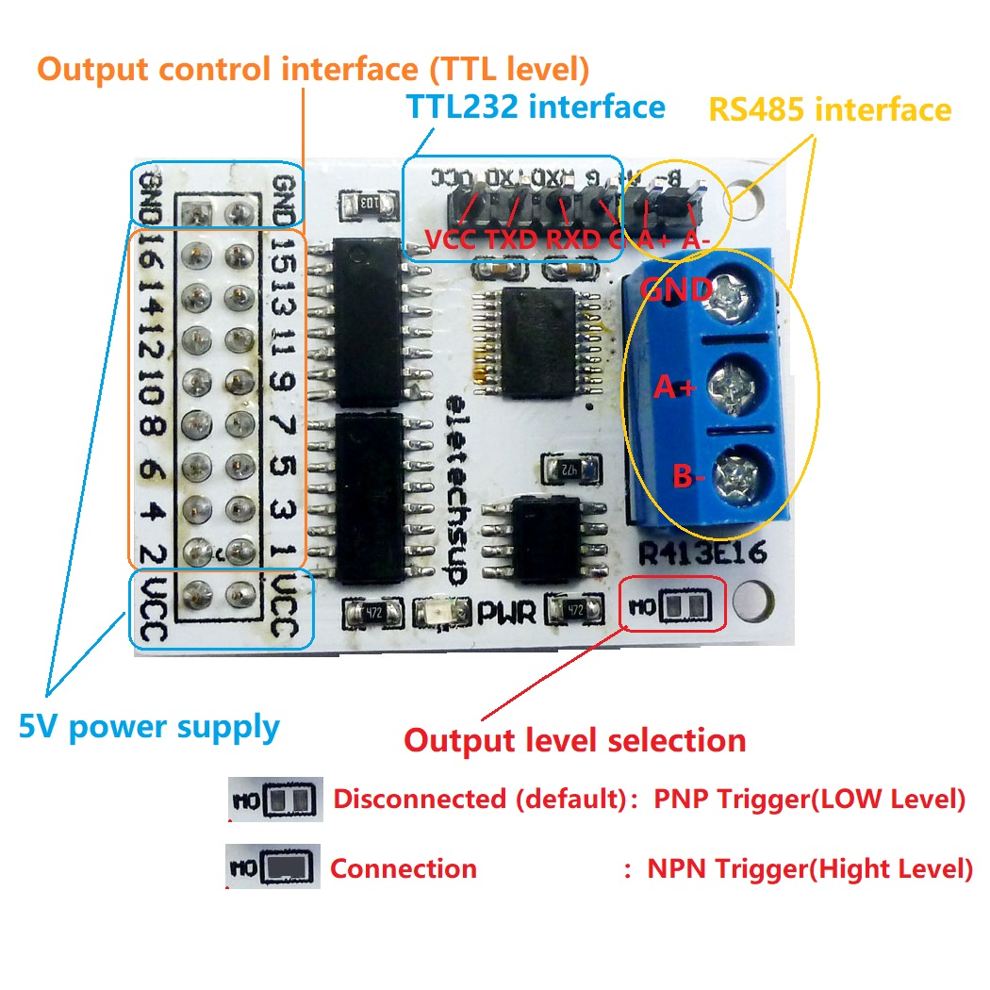
MODBUS command and AT command is automatically recognized, no switching required

Output level selection : ( figure above) M0 disconnect is Low level output. M0 Connect is Hight level output
Slave ID: Different "Sliver ID" can be set by command, the maximum number is 247
Under the MODBUS command mode,the slave ID must be correct
command Description, Please refer to " 16 Channel Multifunction RS485 Module commamd"

Typical applications:
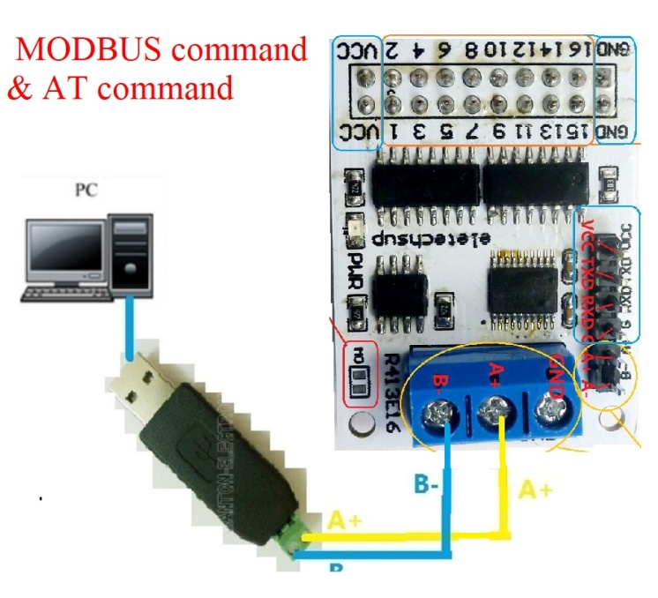
1 AT command mode, in this mode can be through the serial HyperTerminal (serial assistant) enter a simple AT command control relay. AT command mode time up to 9999 seconds
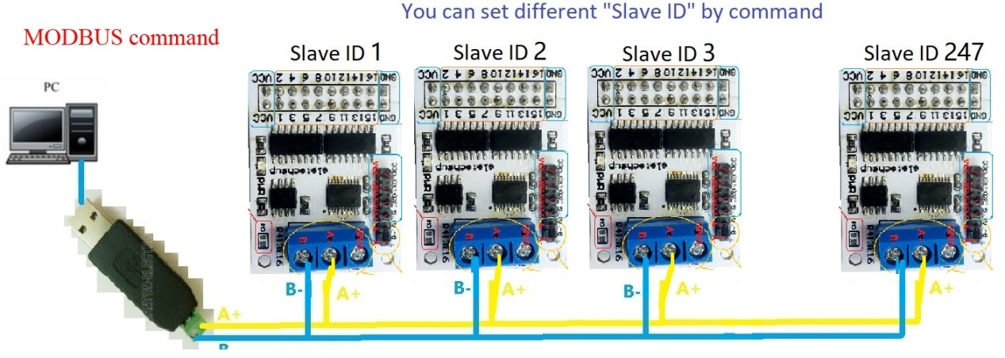
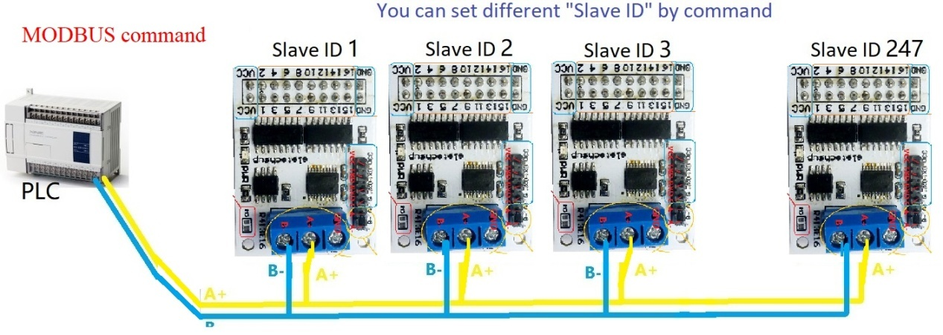
2 MODBUS command mode (HEX), you can control a variety of ways: Serial Hyper Terminal Control (need to manually add the CRC), Modbus Poll software control (software automatically add the CRC), PLC or MCU process control

It can control 1-16 channels Relay Module
(The control board is powered by 5V, but it can control 5-24V relay modules.)
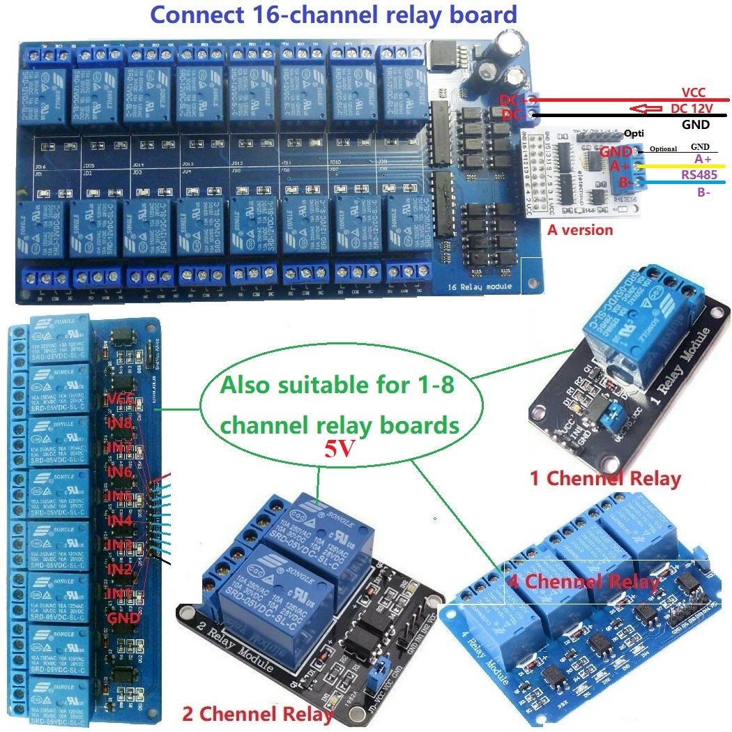

With RS485 interface and RS232 (TTL) interface(It is recommended to remove the SP485 chip)
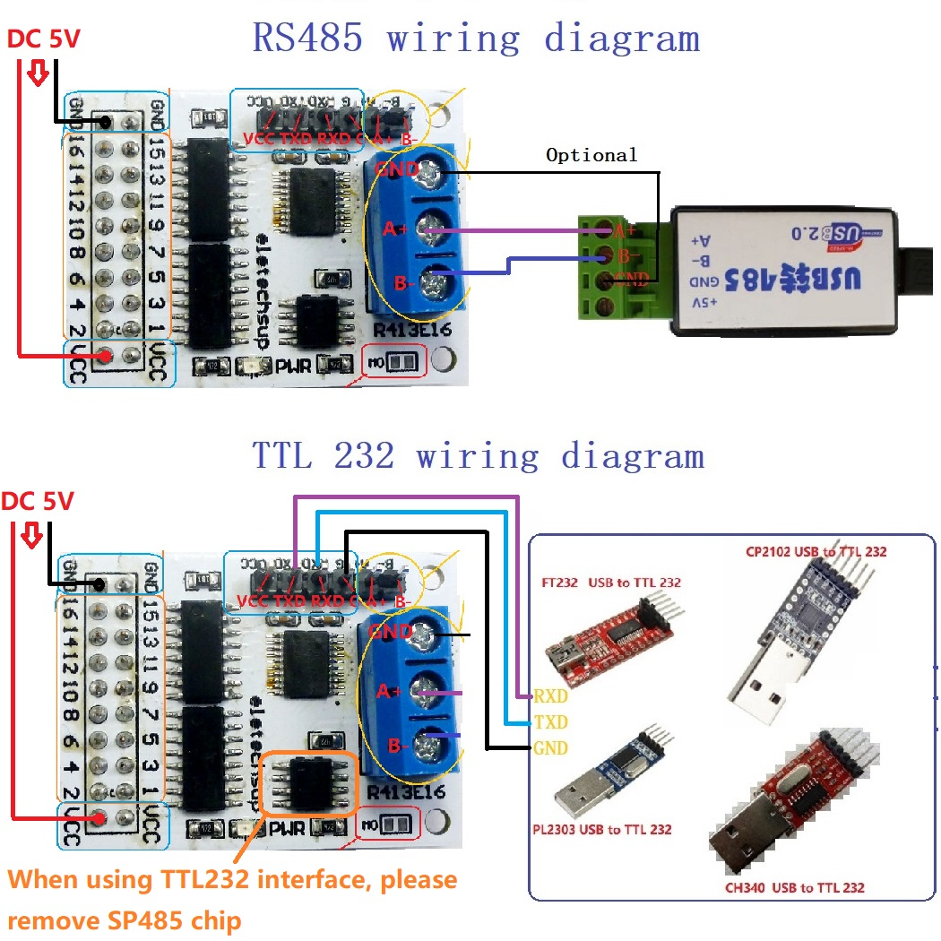

Version identification:
A version for esy insertion into existing relay boards
B version for easy embedding of custom PCB
